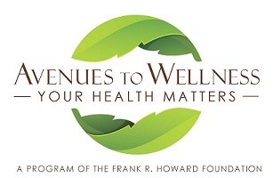

CALLING ALL PROVIDERS!
Howard Foundation, whose mission is to support health in our community for over 65 years, is creating a new program, Avenues to Wellness. An aspect of this program is a health provider directory for the Avenues to Wellness website. We would love for you to be included!

MISSION: To facilitate wellness in our community by providing and promoting innovative and accessible wellness programs, activities, resources and education which encourage health eating, exercise and other affirming behaviors while nurturing the body, mind and spirit.
You are eligible to be part of the new health provider directory if you support the above mission statement and if you:
- Are a professional with a license or certification in good standing in a regulated health profession
- Practice in an established business location
- Have a current business license
- Have or are willing to obtain malpractice insurance

Please complete the following if you would like to be considered as part of this directory of providers. The ATW provider directory will consist of a listing on the ATW website. Referrals will not be made directly to any provider. Completion of this application does not insure your application has been accepted. Your application will be reviewed by our steering committee and you will be informed within 30 days if you are accepted.

Name Date Mailing address Phone Primary office address
Email address website

License or certification modality in which you  would like to be considered as part of the directory: | Date received

