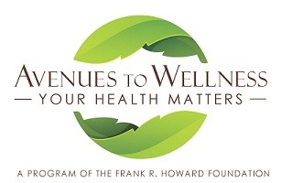

CALLING ALL PHYSICIANS!
Howard Foundation, whose mission has been to support health in our community for over 65 years, has created a program, Avenues to Wellness. An aspect of this program is a health provider directory for the Avenues to Wellness website. We would love for you to be included!

MISSION: To facilitate wellness in our community by providing and promoting innovative and accessible wellness programs, activities, resources and education which encourage healthy eating, exercise and other affirming behaviors while nurturing the body, mind and spirit.

Please complete the following if you would like to be included as part of this directory of providers. The ATW provider directory will consist of a listing on the ATW website. Referrals will not be made directly to any provider.

Name Date

Signature

Name of clinic if applicable

Primary office address

Email address Website

Telephone FAX

Please give a brief description of your practice or specialty:

Please mail this form to:
Avenues to Wellness, Howard Foundation, 3 Marcela Dr. Suite A, Willits, CA 95490 OR
Email the following information to ATWforHEALTH@gmail.com for your listing in the provider directory:
- Name: Name, and if part of a clinic, the name of the clinic.
- Contact Information: Address, Phone, FAX, Email and/or website address.
- Brief description of your practice or specialty.
Please contact Suzanne Picetti at (707) 456-9626 if you have any questions.

